Here is a quick guide on how to use JPing tool

General JPing view:

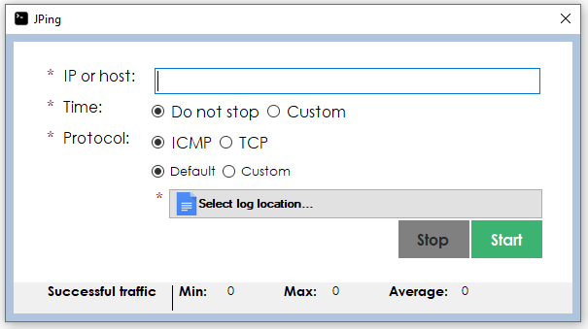

Type the IP or host you would like to ping:

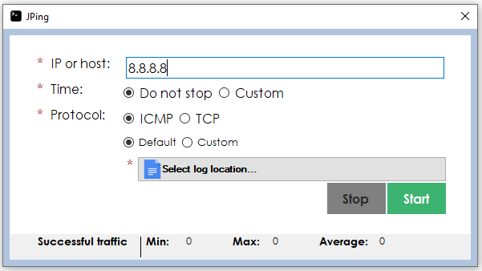

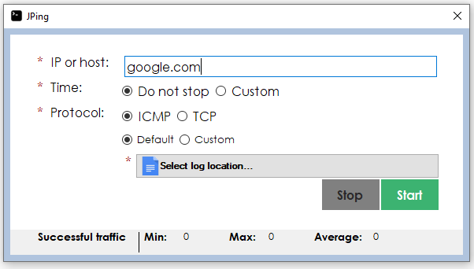

You can customize the number of pings you would like to run or the time you want to have it running:

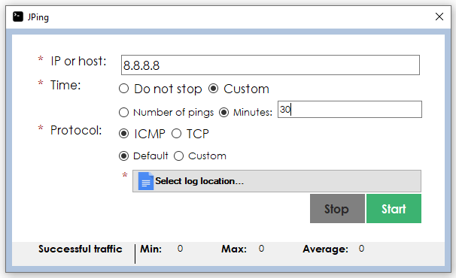

Choose the protocol (ICMP or TCP) you want to use.

If ICMP:

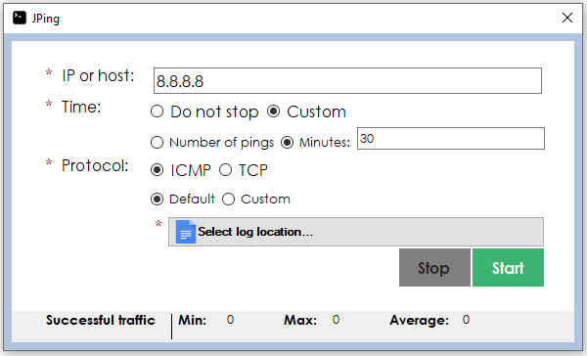

If TCP:

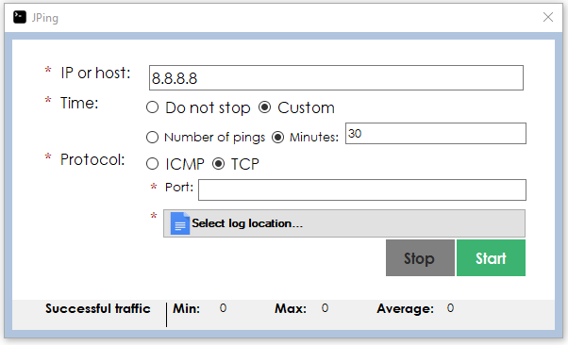

You can customize the ICMP pings selecting the packet bytes and the timeout per ping:

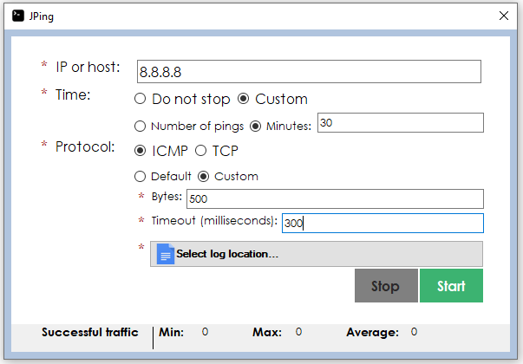

You can customize the TCP port

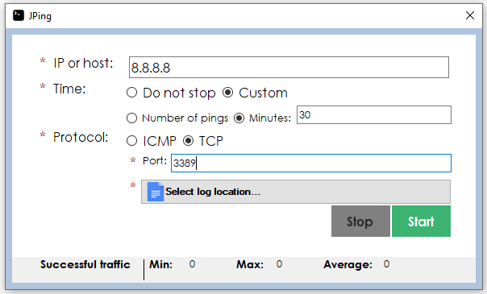

Lastly you will need to select where the log file is going to be saved

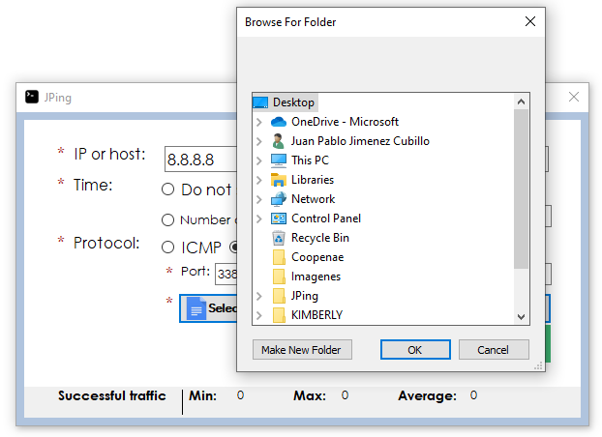

Now just click the **Start** button and the process will start.

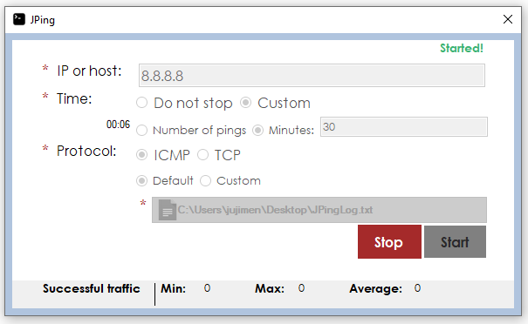

Tool source: \\MININT-EETRFQP\JPing

Tool feedback: \\MININT-EETRFQP\JPingFeedback